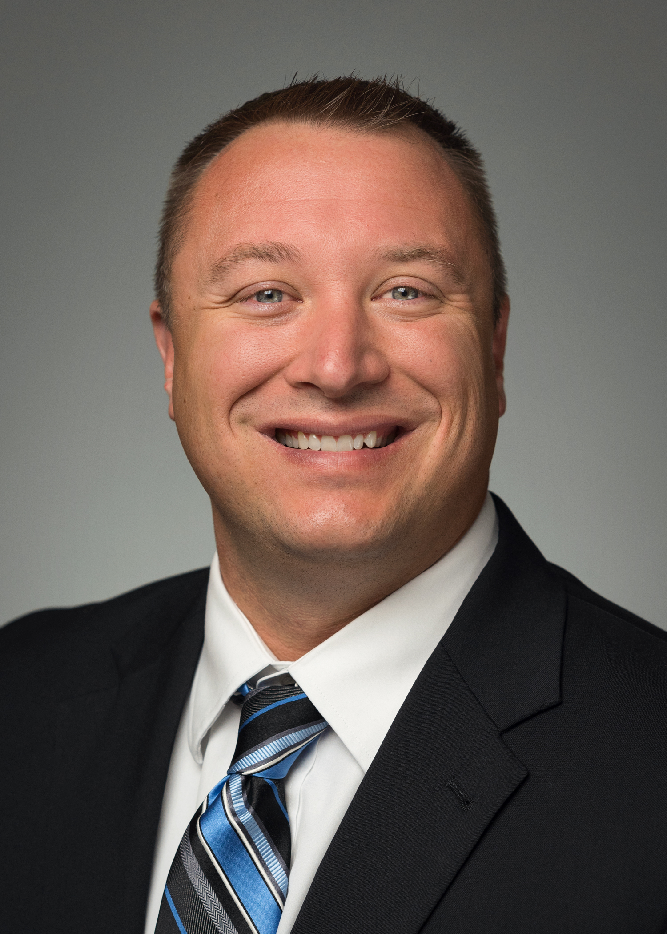 | Steven B. Smith, FACHE, FACMPE, CHFP, CRHCP  Director / Healthcare Performance Improvement  Kansas City, MO / 816.489.4292 / steve.smith@forvis.com
Steve is a member of the Healthcare Performance Improvement practice unit and serves as the practice unit’s lead for rural healthcare performance improvement. He provides consulting services to hospitals, physician practices, Rural Health Clinics (RHCs), Federally Qualified Health Centers (FQHCs), and other provider groups related to revenue cycle performance, operations, RHC establishment, and compliance.
He has presented on Medicare reimbursement and revenue cycle topics as well as numerous operational and payment reform topics for state and local chapters of Medical Group Management Association (MGMA) and Healthcare Financial Management Association (HFMA) as well as multiple state primary care associations and healthcare associations.
Steve is a Fellow of both the American College of Healthcare Executives (ACHE) and the American College of Medical Practice Executives (ACMPE) and has earned the Certified Healthcare Financial Professional (CHFP) designation through HFMA. He also earned the Certified Rural Health Clinic Professional (CRHCP) designation through the National Association of Rural Health Clinics. He is a member of national, state, and local chapters of ACHE, MGMA and HFMA and is an active member in the National Rural Health Association (NRHA). In 2021 Steve was elected to serve a two-year term as a Rural Health Clinics Constituency Group Representative for the NRHA, and currently serves as a member of the NRHA RHC Constituency Group, where he works to advocate for the needs of RHCs across the country.
He is a 2003 graduate of William Jewell College, Liberty, Missouri, with a B.S. degree in business administration, and a 2007 graduate of MidAmerica Nazarene University, Olathe, Kansas, with an M.B.A. degree.

