Jackie King - Director of Hospital Education and ICD-11 Expert
ArchProCoding
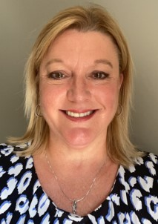
Jackie King, MSHI, CCS, CPC, COC, CRHCP has worked in the health care field for over 35 years in both clinical and administrative positions at small rural and critical access hospitals, RHCs and physician practices. Prior roles include Medical Imaging Technologist, Quality Management and Utilization Review Analyst, and multiple Director roles of Health Information Management (HIM); ACO Compliance; and Clinical Informatics.
She received her Master of Science degree in Health Informatics from the University of Illinois at Chicago in 2012. In 2016 she joined the Illinois Critical Access Hospital Network (ICAHN) as HIM Consultant, Compliance, and Clinical Informatics Director for the Illinois Rural Community Care Organization (IRCCO) Accountable Care Organization (ACO) until July 2022 when she formed JLK Healthcare Consulting as CEO. Jackie continues to work with ICAHN and IRCCO in a consulting capacity. Jackie also joined ArchProCoding as a consultant in January 2019 and continues to serve as their Director of Hospital Education and ICD-11 Expert.
Her primary focuses are providing education, performing documentation and coding audits, sharing resources, promoting efficiency and best practice, and improving health care services for RHCs, small rural and critical access hospitals and their rural communities across the country. Jackie has presented rural health topics nationally both in person and virtually - rural healthcare is her passion! Jackie was born and raised in Freeport, IL and now resides in Rock Falls, IL.

